Robert L. Welker
August 31, 1925 – October 23, 2022

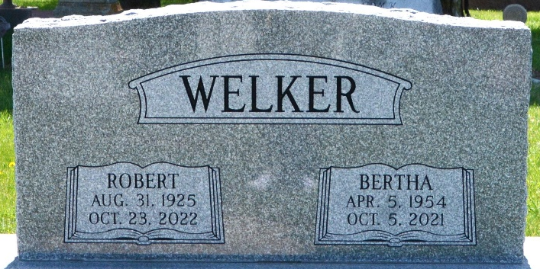
Photo by Deb Curry

Robert (Bob) L. Welker, 97, of Fort Wayne passed away peacefully Sunday, October 23, 2022. He was born on August 31, 1925 in Wren, OH to the late Mathias and Blanche (Shook) Welker.
He owned and operated Welker Auto Sales and Body Shop for over 60 years. He enjoyed the lake, fishing, and boating. He was also a Rusty Wallace NASCAR fan. He enjoyed caring for his own garden and mowing his own yard.
Bob was preceded in death by his wife Bertha, daughter Sandra Baker, and sister Dorothy Girod.
Friends and family may pay their respects Thursday evening (Oct 27) from 5:00 to 8:00 p.m. at Hockemeyer & Miller Funeral Home, 6131 Saint Joe Road, Fort Wayne. He will be laid to rest in Decatur Cemetery.

Fort Wayne Newspapers, Allen County, Indiana
October 24, 2022

