Melvin J. Welker
May 18, 1875 – July 19, 1956

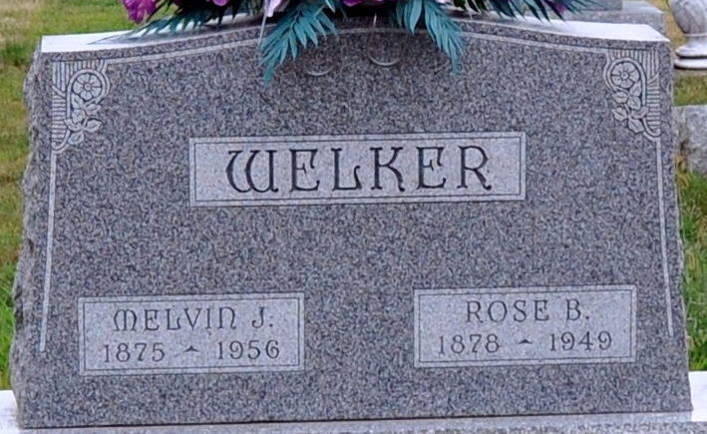
Photo by Deb Curry

Melvin J. Welker Dies Last Evening
Funeral Services Saturday Afternoon
Melvin J. Welker, 81, retired painter and a resident of Decatur most of his life, died at 6 o'clock Thursday evening at the Lutheran Hospital in Fort Wayne, following a cerebral hemorrhage. He had made his home since 1949 with his son, Vere Welker, 3217 Webster Street, Fort Wayne.
He was born in Lima, O., May 18, 1875, and was married to Rose Steele March 6, 1904. Mrs. Welker died March 21, 1949.
Mr. Welker was a member of the First Methodist Church.
Surviving, in addition to the son, are two grandchildren and one brother, Dick Welker of Van Wert, O. Two brothers and one sister are deceased.
Funeral services will be conducted at 3 p.m. Saturday at the Zwick Funeral Home, the Rev. Virgil Sexton officiating. Burial will be in the Decatur Cemetery. Friends may call at the funeral home after 7 p.m. today until time of the services.
Decatur Daily Democrat, Adams County, Indiana
Friday, July 20, 1956

