Matthias S. Welker
April 4, 1904 – March 30, 1988

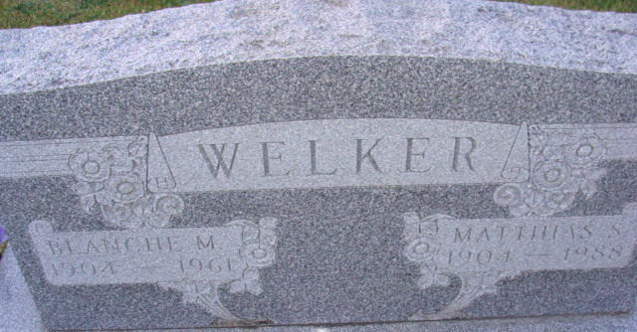
Photo by Alicia Kneuss

Matthias S Welker
in the Indiana, U.S., Death Certificates, 1899-2017
Name Matthias S Welker
Gender Male
Race White
Marital Status Widowed
Age 83
Birth Date 4 Apr 1904
Birth Place Lima, Ohio
Death Date 30 Mar 1988
Death Place Fort Wayne, Allen, Indiana, USA
Death Registration Date 1988
Father Suie T Welker
Mother Sarah C Chronister
Informant Mrs. Bonnie Strickler; daughter; Decatur, Indiana
Burial April 2, 1988; Decatur Cemetery; Decatur, Indiana

