Gertrude Catherine (Gase) Welker
October 8, 1913 – August 10, 2010

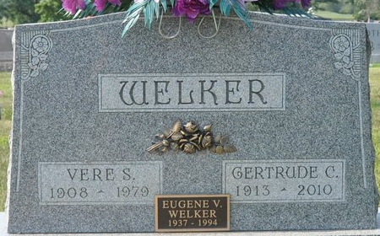
Photo by Deb Curry

Gertude Catharine Gase
in the Indiana, U.S., Birth Certificates, 1907-1944
Name Gertude Catharine Gase
Gender Female
Birth Date 8 Oct 1913
Birth Place Union, Adams, Indiana, USA
Father Philbert Gase; age 36
Mother Katie Diener; age 35; 4th child; all living
Certificate Number 430
Roll number 40474_357360
Volume Range 599 - 605
**
U.S., Newspapers.com™ Obituary Index, 1800s-current
Name Gertrude C Welker
Gender Female
Death Age 96
Birth Date abt 1914
Residence Place Sanibel, Lee, Florida, USA
Death Date 10 Aug 2010
Obituary Date 15 Aug 2010
Obituary Place Fort Myers, Florida, USA
Newspaper Title News-Press
Spouse Vere
Child Gene, Jim

