Eugene Vere Welker
February 18, 1937 – July 22, 1994

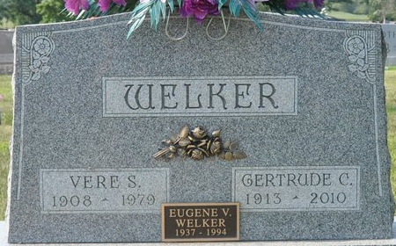
Photo by Deb Curry

Eugene V. Welker, 57, of Fort Myers, Fla., died Friday. The Fort Wayne native was part of Pappy Welker and His Swinging Twins band that played Fort Wayne in the '50s and '60s and later owned the Golden Sand Restaurant on Sanibel Island, Fla., and Outhouse Restaurant in Fort Myers.
Surviving is his wife, Debbie; daughter, Gayle Bireley of Fort Wayne; two sons, including Mitchel of Fort Wayne; mother, Gertrude Welker; and a brother.
Services are 6 p.m. (Florida time) tomorrow in Fort Myers Memorial Gardens Funeral Home.
Preferred memorials are gifts to Hope Hospice, 8290 College Parkway, Suite 100, Fort Myers, FL 33919.

News-Sentinel, Allen County, Indiana
Monday, July 25, 1994

**
Indiana, U.S., Birth Certificates, 1907-1944
Name Eugene Vere Welker
Gender Male
Birth Date 18 Feb 1937
Birth Place Ft Wayne Ind, Allen, Indiana, USA
Father Vere Welker; age 29
Mother Gertrude Gase; age 24; 1st child
Certificate Number 4645; Roll number 40474_357651
Volume Range 6 - 10
**
Florida, U.S., Death Index, 1877-1998
Name Eugene V Welker
Race White
Age at Death 57
Birth Date 18 Feb 1937
Death Date 22 Jul 1994
Death Place Lee, Florida, United States

