Blanche M. (Shook) Welker
May 22, 1904 – February 21, 1961

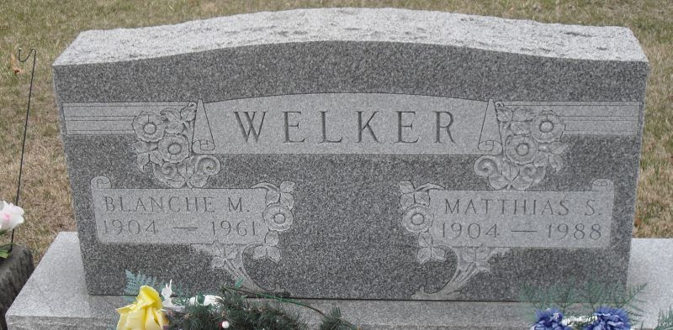
Photo by Stephen & Andrea Brangan
Mrs. Welker Dies after Long Illness
Mrs. Blanche Welker, 56, wife of M. S. (Shorty) Welker of 615 Indiana Street, died at 5:15 o'clock Tuesday evening at the Adams County Memorial Hospital. She had been seriously ill since last September and had been hospitalized the past three weeks.
She was born in Wren, O., May 22, 1904, a daughter of Ben and Sarah Meyers-Shook, and was married to M. S. Welker Feb. 7, 1925. The family has resided in Decatur since 1938. Mrs. Welker was a member of the Wren R.E.U.B. Church.
Surviving in addition to her husband are two daughters, Mrs. Victor (Bonnie) Strickler of Decatur, and Mrs. Lee (Dorothy) Girod of Salem; one son, Robert Welker of Fort Wayne; seven grandchildren; and three brothers, Lawrence Shook of Sturgis, Mich., Theodore Shook of Convoy, OH., and John Shook of Decatur. One daughter, two brothers and four sisters are deceased.
Funeral services will be conducted at 1:30 p.m. Friday at the Zwick Funeral Home, the Rev. Benj. G. Thomas and the Rev. O.B. Turner officiating. Burial will be in the Decatur Cemetery. Friends may call at the funeral home after 7 p.m. today until time of the services.
Adams County Historical Museum, Adams County, Indiana
January 1951 – August 1962 Scrapbook
Handwritten date: Wednesday, February 22, 1961

