Bertha (Yoder) Welker
April 5, 1954 – October 5, 2021

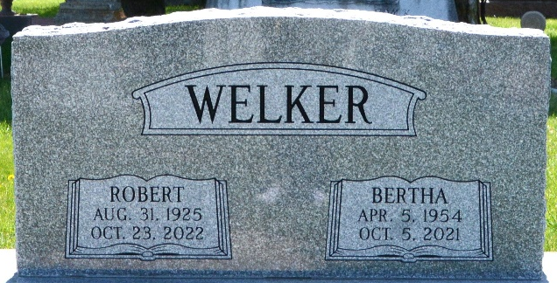
Photo by Deb Curry

Bertha Welker, 67, died Tuesday, October 5, 2021 at Parkview Regional Medical Center in Ft. Wayne, IN. She was born on April 5, 1954 in Michigan to the late Amos & Maggie (Wagler) Yoder. She married Robert Welker on June 2, 1997 in Madison County, Alabama.
Surviving are her husband, Robert Welker of Ft. Wayne; children, Ruth Ann Brenneman of Woodburn, Amy (Tobie) Schmucker of St. Joe, Alvin (Christine) Brenneman of Portland, Rosemary (Aaron) Graber of St. Joe and James Brenneman of Albion; step children, Linda Muldoon, Karen Ferry, Cindy Poellot and Rob Welker; 27 grandchildren; 6 step grandchildren; 6 step great grandchildren; siblings, Catherine Yoder of Warsaw, Rosa (Noah) Graber of Butler, Margaret Graber of Woodburn, Emma Schmucker of Ft. Wayne, Amos (Amanda) Yoder of Topeka, Mary (David) Schwartz of St. Joe, Barbara (Toby) Graber of Vera Cruz and Martha Yoder of Ft. Wayne.
She was preceded in death by a sister, Lizzie Yoder; stepdaughter, Sandy Baker and two step sons-in-law, Steve Muldoon and Dan Ferry.
She was a homemaker who loved doing small crafts and spending time with her family. She attended The Ridge in Ft. Wayne, IN.
Calling will be held on Thursday, October 7, 2021 and Friday, October 8, 2021 from 2-4 & 6-8 pm at Allen County Christian Fellowship (9735 Thimlar Road New Haven, IN 46774). Services will be held on Saturday, October 9, 2021 at 10 am with calling one hour prior at the church.
Graveside Service & burial will be held at 1 pm at Decatur Cemetery (1824 W. Monroe Street Decatur, IN).

Carnahan-Baidinger & Walter Funeral Home
DeKalb County, Indiana

