John Welfley
November 20, 1836 – December 3, 1904
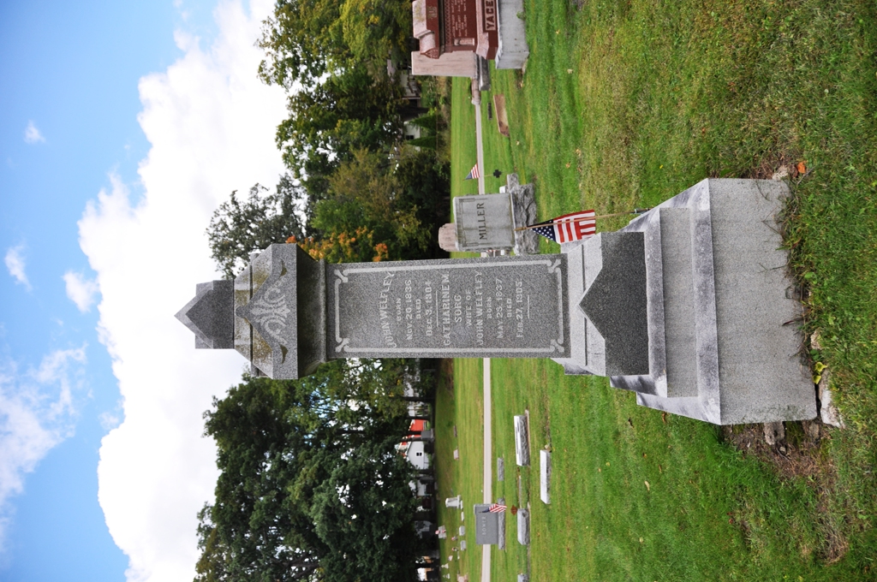
Photo by Deb Curry

DEATH RESULTS - John Welfley Died Saturday Night
Well-Known Citizen - Was Ex-Postmaster of Decatur
In Poor Health Many Years
John Welfley, ex-postmaster of this city and one of the best-known men in the county, died at nine o'clock Saturday evening. For forty years he has suffered more or less from bowel trouble, having contracted the disease while he was in the army. During the past five years, he declined in health perceptibly but was able to do his share of work on his farm. Last Thursday evening while assisting his son Andrew to do some chores about the barn he was suddenly attacked with severe cramps in the stomach. He went into the house when he continued to grow worse. Dr. Clark was summoned but the patient seemed to be beyond medical aid. Friday morning an operation was performed as a last resort to save the patient's life. His age was against him and while he rallied from the shock he was unable to improve, his condition having been weakened by his years of declining health, and the end came forty-eight after the attack.
Mr. Welfley was born in Hanover, Germany, November 20, 1836, and was sixty-eight years and thirteen days old. He came to this country in 1850, locating in Wooster, Ohio, where he grew to manhood. He was married there November 13, 1850, to Miss Catherine Sorg, who survives him.
Three children were born to them, only one of whom Andrew, survives, John and Katie having preceded their father. Mr. and Mrs. Welfly came here shortly after the war was over and have since lived in and near Decatur.
For many years Mr. Welfley conducted a grocery here and was one of the city's most prosperous businessmen. He served as postmaster from 1889 to 1893, shortly after which time he purchased a farm three miles northeast of Decatur, where he has since lived.
He enlisted at Wooster, Ohio, as a private during the Civil War and served three years with honor. He was an honest, conscientious citizen, an indulgent father and husband. Rev. Allen will conduct the funeral services which will be held at the Presbyterian Church Tuesday afternoon at two o'clock.

Decatur Daily Democrat, Adams County, Indiana
Monday, December 5, 1904
**
Indiana, Death Certificates, 1899-2011
Name: John Welfley
Gender: Male
Race: White
Age: 68
Marital Status: Married
Birth Date: abt 1836
Birth Place: Germany
Death Date: 3 Dec 1904
Death Place: Root Tp., Adams, Indiana, USA
Father: Unknown
Mother: Unknown
Spouse: Cathrine Welfley
Informant: Andrew Welfley of Decatur, Indiana
Burial: Dec. 6, 1904 Decatur Cemetery

