Catherine M. (Sorg) Welfley
May 29, 1837 – February 27, 1905
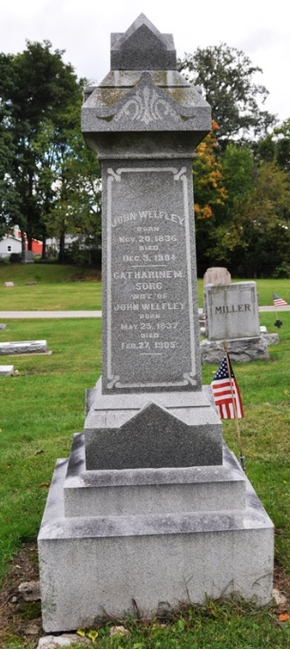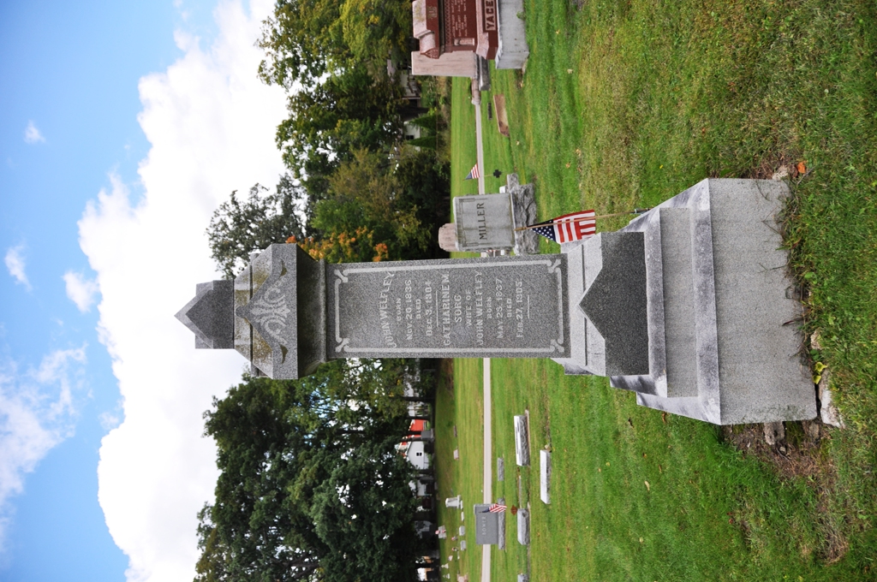
Photos by Deb Curry

GONE TO JOIN HER DEAD HUSBAND
Aged Decatur Widow Wished For Death Since He Was Called
DECATUR, Ind., Feb. 27 – Mrs. Catherine Welfley, sixty-eight years of age, died at her home east of this city, this morning at 7 o'clock, from a complication of diseases. Ever since the death of her husband, ex-Postmaster, John Welfley, a month ago, Mrs. Welfley bemoaned her fate, desiring, she stated, to join her husband. She was one of the oldest residents of this county, coming here from Germany forty-four years ago.
The funeral services will be held Thursday morning at the Presbyterian Church, of which she was a member. She was a sister of Mrs. John Weber, who resides in Fort Wayne.

Journal-Gazette, Allen County, Indiana
February 28, 1905

**
Indiana, U.S., Death Certificates, 1899-2017
Name Mrs Catherine Sorg Welfly
[Mrs Catherine Sorg]
Gender Female; Race White
Marital Status Widowed
Age 67
Birth Date 20 May 1837; Birth Place Germany
Death Date 27 Feb 1905; Death Place Root, Adams, Indiana, USA
Father Sorg; Mother Unknown
Informant Andrew Welfly; Decatur, Indiana
Burial March 1, 1905; Decatur Cemetery

