Russell E. Weldy
March 7, 1897 – October 26, 1949

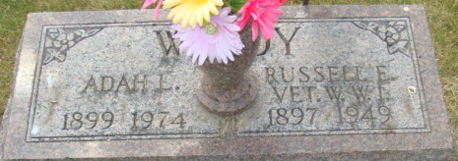
Photo by Alicia Kneuss

Russell Weldy Dies Early This Morning - Funeral Services Friday Afternoon
Russell E. Weldy, 52, veteran of World War I and for nearly 25 years an employee of the Decatur General Electric plant, died at1:30 o'clock this morning at his home, 416 South Fifth Street, following a year's illness of complications.
He was born March 7, 1897 in Mercer County, O., a son of Jesse M. and Myrtus Cross-Weldy, both of whom survive. He was married March 23, 1918 to Adah L. Click.
He was a member of the Church of God, Adams Post 43, American Legion, 40 & 8, and the Loyal Order of Moose.
Surviving in addition to his parents and wife are three children, Mrs. Marjorie Terrell of Decatur, Jack M. Weldy and Miss Wauneta A. Weldy, both at home; a foster son, Roy Shoaf of Lafayette; two brothers, W. V. Weldy of LaCrosse, Wis. and L. F. Weldy of Niles, Mich; two sisters, Mrs. K. F. Strape of Fort Wayne and Mrs. R. C. Sallenberger of Washington, D.C. and two step-grandchildren.
Private funeral services will be held at 2 p.m. Friday at the Black Funeral Home the Rev. Dwight P. McCurdy officiating. Burial will be in the Decatur Cemetery with Adams Post 43, American Legion, conducting military rites. Friends may call at the funeral home from 7 to 10:30 p.m. Thursday.
Friends are requested to omit flowers but may make contributions to the cancer fund.
Decatur Daily Democrat, Adams County, Indiana
Wednesday, October 26, 1949

