Adah L. (Click) Weldy
February 26, 1899 – November 17, 1974

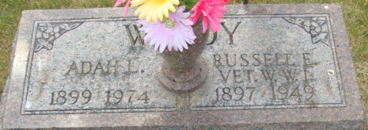
Photo by Alicia Kneuss

Adah Weldy Dies Sunday at Age 75
Adah L. Weldy, 75, of 410 S. Fifth St., died at 5:45 p.m. Sunday at the Adams County Memorial Hospital following an extended illness.
Mrs. Weldy, who was born in Adams County on February 26, 1889 to Franklin J. and Nancy Galloway Click, was married on March 23, 1918 to Russell E. Weldy, who passed away in 1949.
A housewife, Mrs. Weldy was a member of the auxiliaries of the VFW, DAV and Eagles.
Surviving are four children: Roy E. Shoaf of Decatur, Mrs Von (Marjory) Terrell of route 5, Huntington, Jack M. Weldy, with who Mrs. Weldy resided, and Mrs. Donald A. (Wauneta) Smith of Van Wert, O. Also surviving are a sister, Mrs. Myrtle Fredericks of Dayton, a brother, Charles Click of Fort Wayne, six grandchildren and five great-grandchildren. Four sisters and two brothers are deceased.
Funeral services will be held at 10:30 a.m. Wednesday at the Winteregg-Linn & Haggard Funeral Home, Rev. John Kinner in charge. Friends may call at the funeral home from 7 to 9 p.m. tonight and from 5-9 p.m. Tuesday. The VFW, DAV and Eagles auxiliaries will hold services beginning at 6 p.m. Tuesday. Burial will be in the Decatur cemetery.
Decatur Daily Democrat, Adams County, Indiana
Monday, November 18, 1974

