Lulu Pearl (Teeple) Welch
September 30, 1894 – June 4, 1919

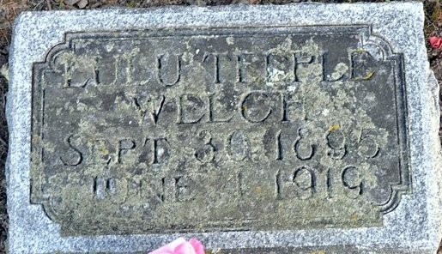
Photo by Deb Curry

DIES SUDDENLY
(Special to the News) - Decatur, IN., June 5 – Mrs. Lulu Welch, wife of Jesse Welch and daughter of Mr. and Mrs. Henry I. Teeple, died very suddenly yesterday, believed to be due from smothering while falling face downward during an attack of epilepsy or a fainting attack to which she was subject. She was found dead.
Funeral services will be held at the Pleasant Mills Methodist Church Friday afternoon.
A divorce suit is now pending in the circuit court, brought by the husband, who claims that he did not know until after the marriage that she was subject to epilepsy. They had lived together a number of years before he brought the suit. A divorce was refused recently, but is still on the docket pending action on a petition for a new trial.
Fort Wayne News, Allen County, Indiana
Thursday, June 5, 1919
**
Indiana, U.S., Death Certificates, 1899-2017
Name Lula Pearl Welch
[Lula Pearl Teeple]
Gender Female
Race White
Marital Status Married
Age 24
Birth Date 30 Sep 1894
Birth Place Ohio
Death Date 4 Jun 1919
Death Place Blue Creek, Adams, Indiana, USA
Death Registration Date 1919
Father Henry I Teeple
Mother Rebecca Miller
Spouse Jesse Welch
Informant Rebecca Teeple; Decatur, Indiana
Burial June 6, 1919; Decatur Cemetery
**
Zwick Funeral Home Records 1918-1922
Name of Deceased Lulu Pearl Teeple Welch
Casket No. 662 3/4; A. Int; Northern Casket Co.; Size 6' 3"; $400.00
Metal Vault Style February 24, 1900
Burial Robe Dress; $20.00; Slippers Small; $3.00
Flowers Basket; Cost ?; Pillow, white & pink, Name (Lulu); $6.00
Date of Funeral June 6, 1919
Date of Death June 04, 1919
Place of Death Blue Creek Township, Adams County, Indiana
Place of Funeral Pleasant Mills ME Church
Date of Burial June 6, 1919
Where Interred Decatur Cemetery
Born September 30, 1895
Age 23 years, 8 months, 4 days
Color White; Occupation Housekeeper
Status Married
Birthplace Spencerville, Ohio
Last Place of Residence Blue Creek Township, Adams County, Indiana
Father's Name Henry Irwin Teeple; Country of Birth Iowa
Mother's Name Rebecca E. Miller; Country of Birth Van Wert County, Ohio
Physician Coroner D. D. Clark
Ordered By H. I. & Rebecca Teeple
Charge To H. I. & Rebecca Teeple
When Rendered June 6, 1919;
Received on Account September 1, 1920; by ck per H. I. Teeple; $150.00
Received on Account October 13, 1920; part of note per John; $246.00
Received on Account December 24, 1920; by ck per H. I. Teeple; $96.00 (PAID $492.00)

