Permillia Emma (Stevens) Weis
February 18, 1876 – December 7, 1949

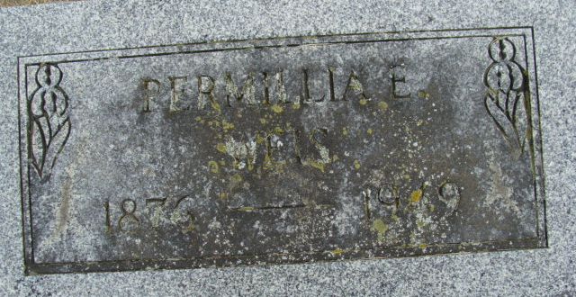
Photo by Alicia Kneuss

Mrs. Purmelia Weis Dies Last Evening
Funeral Services Saturday Afternoon
Mrs. Purmelia Weis, 73, widow of Adam Weis, and a lifelong resident of Adams County, died at 10 o'clock Wednesday night at her home, 112 East Oak Street. She had been in failing health for three years and critically ill for the past week.
She was born in Union Township Feb. 18, 1876, a daughter of Smith and Sarah Jane Stevens, and was married to Adam Weis Sept. 2, 1897.
She was a member of the Zion Evangelical and Reformed Church, the Pythian Sisters and a charter member of the Ben Hur Lodge.
Surviving are a brother, Clinton Stevens, of Decatur, and three sisters, Mrs. Mary Pierce and Mrs. Ruth Webster, both of Monroeville, and Mrs. Ethel Roth of Paulding. O. Four brothers and two sisters preceded her in death.
Funeral services will be held at 1:15 p. m. Saturday at the Black Funeral Home and at 1:30 o'clock at the Zion Evangelical and Reformed Church, the Rev W. C. Feller officiating. Friends may call at the funeral home after 10 a. m Friday.
Decatur Daily Democrat; Adams County, Indiana
Thursday, December 8, 1949
**
Indiana, U.S., Death Certificates, 1899-2017
Name Purmelia Emma Weis
[Purmelia Emma Stevens]
Gender Female
Race White
Marital Status Widowed
Age 73
Birth Date 18 Feb 1876
Birth Place Adams County, Indiana
Death Date 7 Dec 1949
Death Place Decatur, Adams, Indiana, USA
Death Registration Date 1949
Father Smith Stevens
Mother Sara Jane Crozier
Informant Clint Stevens; Decatur, Indiana
Burial December 10, 1949; Maplewood Cemetery; Decatur, Indiana

