Roger Allen Weimer
August 27, 1961 – March 10, 2013

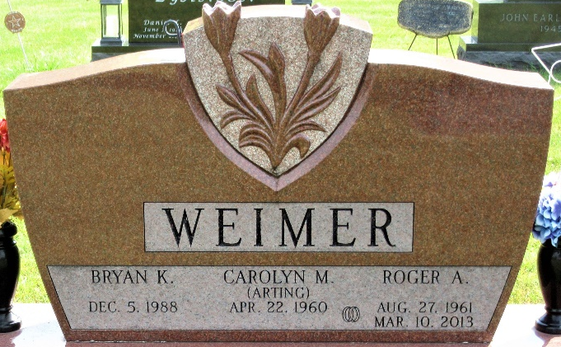
Photo by PLS

Roger Allen Weimer, 51, passed from this life on March 10, 2013 in Tulsa, Oklahoma. Roger was born on August 27, 1961 in Kendallville, Indiana to Keith and Velma Jean (Morrison) Weimer. He met and married Carolyn Arting on July 20, 1985 in Azalea, Michigan and they shared 27 memorable years together.
Roger was a jack of all trades but most recently was a Broken Arrow Public School Bus Driver. Roger loved sports and was an avid Oklahoma University and Indianapolis Colts fan. He collected fatheads as well.
Roger is survived by his loving wife, Carolyn Weimer of Broken Arrow, Oklahoma. His children, Bryan Weimer of Broken Arrow; Jessica Ann Weimer of Kendallville; and Justin and Tia Weimer of Ossian.
Grandchildren, Andrew Doughty, Joseph Doughty, Aliyah Hall, Landen Hall, and Kaitlynn Weimer. Parents, Keith and Velma Jean Weimer of Avilla. Brothers, Rick and Lisa Weimer of Crystal Lake, Illinois and Ron and Laurie Weimer of St. Joseph, Michigan.
The Weimer nieces and nephews, Amanda and Morgan Weimer, Kenzie, Nic and Brie Weimer and Morgan Zelmer. Also many nieces and nephews from Carolyn’s side of the family.
He was preceded in death by his son, Ryan Matthew Weimer.
Visitation will take place on Friday, March 15, 2013 from 5:00-8:00pm at Hite Funeral Home in Kendallville. Funeral services will be held Saturday, March 16, 2013 at 11:00am at Hite Funeral Home in Kendallville, Indiana. There will also be visitation from 9-11:00am before the funeral on Saturday. Burial will be at the Decatur Cemetery in Decatur, Indiana.

Hite Funeral Home, Noble County, Indiana
March 10, 2013

