Martha M. (Niblick) Weimer-Chilcoat
July 6, 1824 – January 15, 1900

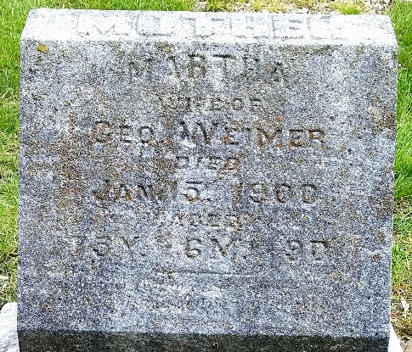
Photo by Deb Curry

Mrs. Martha M. Chilcoat died at the home of her daughter, Mrs. Fred Schafer, last Monday after an illness of several years. She was a woman of strong religious principles and was loved and esteemed by all who knew her.
Funeral services were conducted from the Schafer home at 11:30 a. m. yesterday by Rev. Daniel, who said: The subject of this memior was born in Tuscarawas County, Ohio, July 6, 1824; died in Decatur, January 15, 1900; aged 75 years, 6 months and 9 days. Her parents came to Indiana when she was ten years of age and settled upon a farm two miles west of Decatur. All this portion of Indiana was then largely an unbroken forest, inhabited by wild animals and untutored Indians. In the midst of these surroundings, imbibing the strength which they imparted, the deceased spent her girlhood days.
At about the age of 22 she was united in marriage to Geo. Weimer, who died in 1862. All the children of this union passed away in early life, except the two daughters, Mrs. Sarah Schafer and Mrs. Ollie Meibers, who mourn today the death of a precious mother. This is one of the greatest losses that can be sustained by any heart or home. In 1879 she was joined in marriage to Samuel Chilcoat, who died about twelve years ago.
Decatur Democrat; Adams County, Indiana
Thursday, January 18, 1900
**
Indiana, U.S., Death Certificates, 1899-2017
Name Martha Chilcoat
[Martha Niblick]
Gender Female
Race White
Marital Status Single
Age 75 years, 6 months, 3 days
Birth Date abt 1825
Birth Place Ohio
Death Date 15 Jan 1900
Death Place Decatur, Adams, Indiana, USA
Death Registration Date 1899-1900
Father Robert Niblick
Mother Lydia Valentine
Informant Fred Shaffer; Decatur, Indiana
Burial January 17, 1900; Maplewood Cemetery; Decatur, Indiana
**
Indiana, U.S., Marriage Certificates, 1960-2012
Name Martha F Weimer
Gender Female
Marriage License Date 9 Mar 1870
Marriage Date 11 Mar 1870
Marriage Place Wells, Indiana, USA
Spouse Lemuel E Louther
**
Ohio, U.S., County Marriage Records, 1774-1993
Name Martha Sawther/Lawther
Gender Female
Marriage Age over 18
Birth Date
Marriage Date 15 Jan 1880
Marriage Place Van Wert, Ohio, USA
Spouse Samuel L Chilcoat
Film Number 001015861

