Bryan K. Weimer
December 5, 1988 -

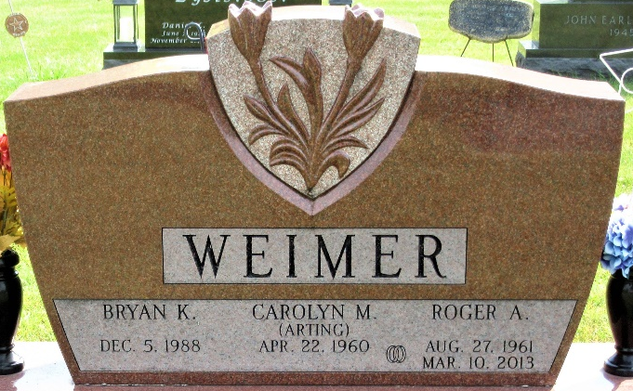
Photo by PLS

