Robert A. Weiland
June 30, 1939 – January 10, 2019

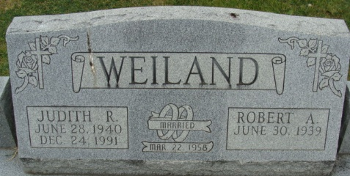
Photo by Alicia Kneuss
Robert A. “Bob” Weiland Sr., 79, of Fort Wayne, Indiana passed away Thursday evening, January 10, 2019 at his home surrounded by his family following an illness. He was born on June 30, 1939 in Adams County, Indiana to the late Wilson C. F. Weiland & the late Helen M. (Busick) Weiland. Bob was married to Judith Goldner on March 22, 1958 at Mt. Pleasant Church and she preceded him in death on December 24, 1991. On October 16, 1992, he married Phyllis Ochse in Fort Wayne, Indiana and she survives. Bob served his country in the Air National Guard. He was a member of Zion Lutheran Church in Decatur. He retired from Fort Wayne Wire Die following over 48 years of service. Following his retirement, Bob worked for Lynn French for ten years.
Bob was a wonderful husband, father, grandfather, great-grandfather, friend, and mentor. Bob enjoyed tinkering around his house and making creative treasures for his grandchildren. Playing Aggravation with his brother and wife were also a favorite pastime for Bob…an opposite for Bob because he possessed a calm demeanor.
He is survived by his wife of 26 years, Phyllis Weiland of Fort Wayne; son, Robert “Butch” (Angela) Weiland Jr. of Decatur; son, Gregory (Barbara) Weiland of Geneva; son, Gary H. (Kristie) Weiland of Decatur; daughter, Cassie Hammond of Decatur; son, Danny (Robin) Jackson of Fort Wayne; son, Tim (Julie) Jackson of Byron Center, MI; son, Jeff (Leslie) Jackson of Fort Wayne; daughter, Tammy Shaw of Fort Wayne; three brothers, Lynford (Annie) Weiland, Richard (Jo) Weiland, & David (Rosie) Weiland all of Decatur; 29 grandchildren; 48 great-grandchildren; and one great-great- granddaughter.
Bob was preceded in death by four grandchildren, Mason Christian Hammond, Shawn Jackson, Randy Weiland, & Alicia Roberts; a great-grandson, Shaun Hammond; and his son-in-law, Barry Shaw.
A funeral service will be held at 1:00 p.m. Tuesday, January 15, 2019, at Zion Lutheran Church located at 1010 West Monroe Street in Decatur with Pastor James Voorman officiating. Interment will follow at Decatur Cemetery. Family & friends will be received from 2 to 5 and 6 to 8 p.m. Monday, January 14, 2019 at Zwick & Jahn Funeral Home in Decatur and one hour prior to services Tuesday at the church.
Preferred memorials are to Riley Hospital for Children; St. Jude Hospital; Ronald McDonald House; or Zion Lutheran Church.

Zwick & Jahn Funeral Home, Adams County, Indiana
Friday, January 11, 2019

