Judith Rose (Goldner) Weiland
June 28, 1940 – December 24, 1991

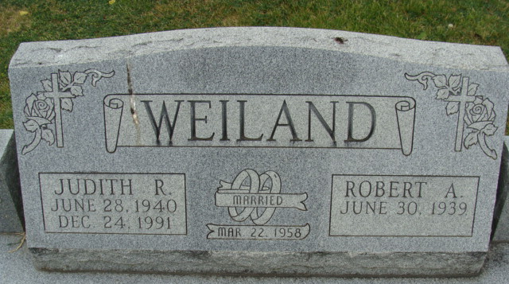
Photo by Alicia Kneuss
Judith Rose Goldner
in the Indiana, U.S., Birth Certificates, 1907-1944
Name Judith Rose Goldner
Gender Female
Birth Date 28 Jun 1940
Birth Place Bluffton, Wells, Indiana, USA
Father Truman Herman Goldner; age 38
Mother Pearl Massey; age 32; 4th child, all living
Certificate Number 29332
Roll number 40474_357733
Volume Range 56 - 60
**
Ohio, U.S., Death Records, 1908-1932, 1938-2022
Name Judith R Weiland
[Judith R Goldner]
Gender Female; Race White
Marital Status Married
Death Age 51
Birth Date 28 Jun 1940
Birth Place Indiana, USA
Residence Place Adams, Indiana, USA
Death Date 24 Dec 1991
Death Place Cleveland, Cuyahoga, Ohio, USA
Death Hospital Hospital/Inpatient
Industry Nursing and Personal Care Facilities
Occupation Nursing Aides, Orderlies, and Attendants
Education 11
Filing Date 27 Dec 1991
Father Goldner
Certificate Number 088630
Inquest Hospital Cleveland Clinic Hospital
Inquest Questions Place of Injury: Unspecified Place; Injury in Ohio?: Yes; Referred to Coroner?: Not Referred to Coroner; Certifier: Physician; Autopsy Performed?: Autopsy Performed; Time of Death: 11:45 Pm

