Viola (Tewers) Weidler
May 15, 1900 – May 17, 1976

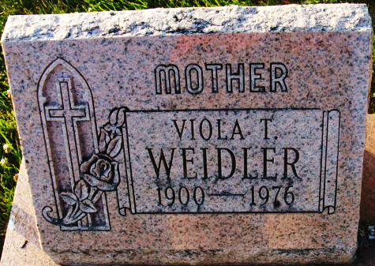
Photo by Alicia Kneuss

Viola T Wiedler
in the Indiana, U.S., Death Certificates, 1899-2017
Name Viola T Weidler
[Viola T Tewers]
Gender Female
Race White
Marital Status Married
Age 76
Birth Date 15 May 1900
Birth Place Ohio
Death Date 17 May 1976
Death Place Decatur, Adams, Indiana, USA
Death Registration Date 1976
Father Herman Tewers
Mother Lizzette Nagel
Spouse Frederick Calvin Weidler
Informant Frederick C. Weidler; husband; Decatur, Indiana
Burial May 20, 1976; Decatur Cemetery; Decatur, Indiana

