Ricky James Weidler
March 20, 1969 – March 21, 1969

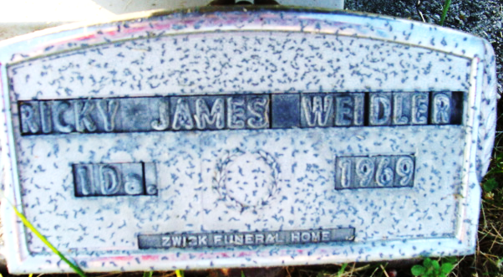
Photo by Alicia Kneuss

Weidler Infant Dies at Hospital
Ricky James Weidler, day-old son of Don and Ann Logan-Weidler, died at 8:55 a.m. Friday at the Parkview Memorial Hospital in Fort Wayne, where the infant was born Thursday.
The parents, who resided at 844 Mercer Avenue, Decatur, are members of St. Matthew's Lutheran Church in Fort Wayne. The father is manager of the automotive department at K-Mart in Fort Wayne.
Surviving in addition to the parents are two brothers, Chris and John; the paternal grandparents, Mr. and Mrs. Fred Weidler of Ossian Route 2; the maternal grandmother, Mrs. Ellen Right of Fort Wayne, and the maternal great-grandmother, Mrs. Bertha Steele of Orlando, Fla.
Graveside services conducted by the Zwick Funeral Home, will be held at 4 p.m. Sunday at the Decatur Cemetery with Rev. William C. Feller officiating.
Decatur Daily Democrat, Adams County, Indiana
Saturday, March. 22, 1969
**
Indiana, U.S., Death Certificates, 1899-2017
Name Ricky James Weidler
Gender Male
Race White
Age 1 day
Birth Date 20 Mar 1969
Birth Place Indiana
Death Date 21 Mar 1969
Death Place Fort Wayne, Allen, Indiana, USA
Father Don Weidler
Mother Ann Logan
Informant: Don Weidler; father; Decatur, Indiana
Burial: March 23, 1969; Decatur Cemetery; Decatur, Indiana

