Lucretia “Billie” (Chandler) Weidler
May 30, 1925 – February 8, 1984

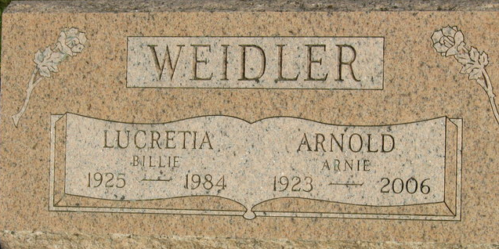
Photo by S. Riley
LUCRETIA B. WEIDLER
Lucretia “Billie” Weidler, 58, route 1, Geneva, active in the Girl Scout program for 20 years, died at 10:30 a.m. Wednesday at the Adams County Memorial Hospital, where she had been a patient since Sunday. She suffered a heart attack.
She was a member of the St. John United Church of Christ at Vera Cruz and filled many positions in the Girl Scout program. Born in Oklahoma City, Okla., on May 30, 1925, she was the daughter of William and Lucretia Hogan-Chandler, and was married Dec. 16, 1944 in Oklahoma City, to Arnold N. Weidler; he survives.
Also surviving are five children, Mrs. Don (Nancy) Barger, Craigville, 1st Class Petty Officer Dan E. Weidler, Glenview Naval Air Station, Glenview, Ill.; Jim A. Weidler, Fort Wayne; Mrs. George (Arlene) Kuntzman, St. Mary’s, O.; Mrs. James (Tami) Seem, Berne; and eight grandchildren.
Services will be held Saturday at 10:30 a.m. at the Zwick, Boltz & Jahn Funeral Home, with Revs. John Niederhaus and George W. Kuntzman officiating. Burial will be in the Decatur Cemetery.
Friends may call at the funeral home from noon Friday until time of the services Saturday.

Decatur Daily Democrat, Adams County, Indiana
Thursday, February 9, 1984

