Lillian Bernice (Kenney) Weidler
October 28, 1897 – February 23, 1994

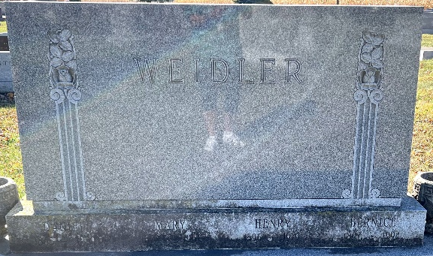

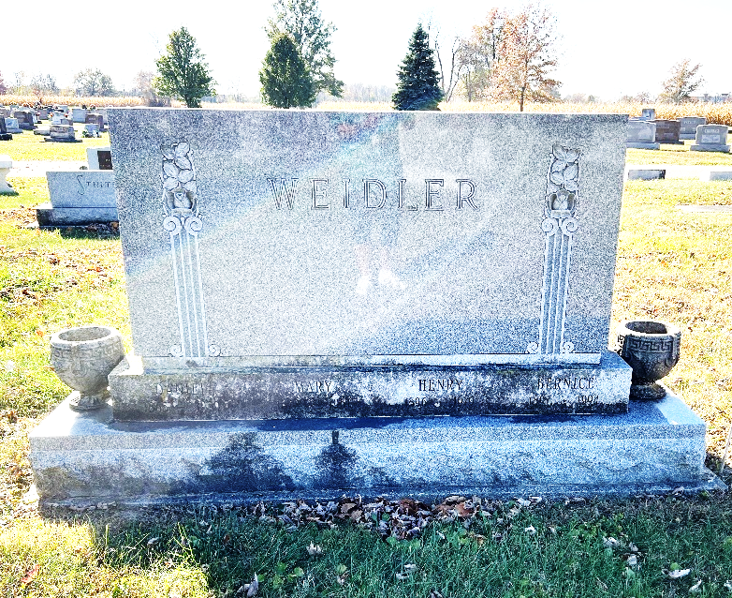
Photo by Deb Curry

Lillian Bernice Kenney from tree My DNA-linked Main Family Tree
Birth 28 Oct 1897 Providence, Providence, Rhode Island, USA
Marriage 10 May 1920 Detroit, Wayne, Michigan, USA
Residence 1951 Michigan, USA
Death 23 Feb 1994 Saginaw, Saginaw, Michigan, USA
Father Willard Elmer Kenney (1870-1952)
Mother Lillian Ervella Fish (1873-1953)
Spouse Henry Carl Weidler (1896-1979)

