Henry Carl Weidler
August 31, 1896 – April 20, 1979

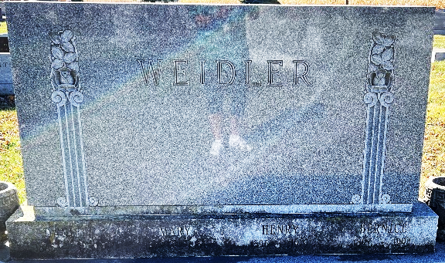

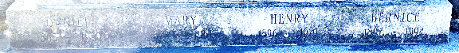
Photos by Deb Curry

Henry C Weidler
in the Michigan, U.S., Marriage Records, 1867-1952
Name Henry C Weidler
Gender Male
Race White
Age 23
Birth Date abt 1897
Birth Place Indiana
Marriage Date 10 May 1920
Marriage Place Detroit, Michigan, USA
Residence Place Detroit, Michigan
Father Daniel Weidler
Mother MaryConrad
Spouse Lillian B Kenney
Record Number 193747
**
North Carolina, U.S., Death Indexes, 1908-2004
Name Henry Carl Weidler
Gender Male
Race White
Marital Status Married
Age 82
Birth Date 31 Aug 1896
Birth Place Indiana, USA
Residence Place Henderson, North Carolina
Death Date 20 Apr 1979
Death Place Hendersonville, Henderson, North Carolina
Social Security Number xxx
Source Vendor NC Department of Health. North Carolina Deaths, 1979-82
Notes Disposition: Cremation in state, Attendant: Physician, Hospital Status: General Hospital
**
Henry Carl Weidler from tree Peters Family Tree
Birth 31 Aug 1896 Indiana, USA
Marriage 10 May 1920 Detroit, Wayne, Michigan, USA
Residence 1950 Grosse Pointe Park, Wayne, Michigan, USA
Death 20 Apr 1979 Hendersonville, Henderson, North Carolina, USA
Father Daniel Weidler (1865-1950)
Mother Maria Conrad (1873-1951)
Spouse Lillian Bernice Kenney (Born 1898)

