Catherine Elizabeth Weidler
February 9, 1910 – July 3, 1997

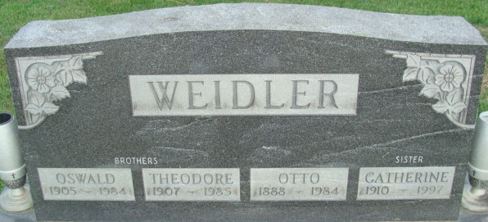
Photo by Alicia Kneuss
Catherine Elizabeth Weidler, 87, died Thursday at Joh Younger Special Care Center, Midland, Texas. The Decatur native taught at Monmouth and Bellmont High School for 43 years.
Surviving are two brothers, the Rev. Victor Weidler of Tripoli, Iowa, and the Rev. Edwin Weidler of Cloudcroft, New Mexico.
Services at 10 a.m. Tuesday at Zion United Church of Christ. Calling from 2 to 4 and 6 to 8 p.m. Monday at Haggard & Armes Funeral Home, and one hour before services at the Church. Burial in Decatur Cemetery.
Memorial to the Church or to Hospice of Midland Inc., P.O. Box 2621, Midland, Tx 79702

Journal Gazette, Allen County, Indiana
Saturday, July 5, 1997
**
Indiana, U.S., Birth Certificates, 1907-1944
Name Catherine Weidler
Gender Female
Birth Date 9 Feb 1910
Birth Place Root, Adams, Indiana, USA
Father Jacob Weidler; age 46
Mother Catherine Canesburg; age 40; 10th child, all living
Certificate Number 85; Roll number 45385_358732
Volume Range 251 - 255
**
Texas, U.S., Death Index, 1903-2000
Name Catherine Weidler
Death Date 3 Jul 1997
Death County Midland
Gender Female

