Arnold N. Weidler
December 13, 1923 – January 23, 2006

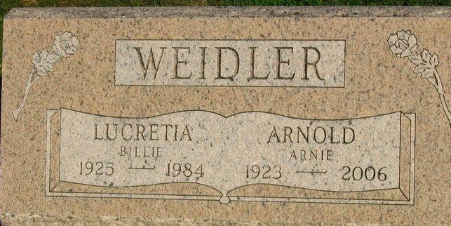
Photo by S Riley

Arnold N. Weidler, 82, of Decatur died at 6 a.m. Monday, Jan. 23, 2006, at Lutheran Hospital in Fort Wayne. He had retired from Phelps-Dodge in Fort Wayne in 1986 after 30 years of service. Mr. Weidler was a member of St. John's United Church of Christ in Vera Cruz.
Born Dec. 13, 1923, in Adams County to Fred C. and Viola S. (Tewers) Weidler, his marriage on Dec. 16, 1944, in Oklahoma City, Okla., was to Billye Chandler, who died on Feb. 8, 1984. His marriage on Nov. 19, 1988, in Vera Cruz was to Marjorie L. Withrow, who survives.
Other survivors include daughters Mrs. James (Nancy C.) Brown of New Haven, Mrs. Wes (Arlene J.) Kuntzman of Monroe and Tami L. Seem of Wapakoneta, Ohio; sons Dan E. Weidler of Ventura, Calif., and James A. Weidler of Kokomo; a stepdaughter, Mrs. Ron (Nancy M.) Smith of Ogden, Utah; a stepson, Al Withrow of Berrien Springs, Mich.; sisters Anna Laura Hirschy of Berne and Mrs. Stan (Mary Emma) Lyons of Upland; brothers Wilfred J. Weidler and Paul H. Weidler, both of Haines City, Fla., Rudolph C. Weidler of Clinton, Md., and Donald F. Weidler of Decatur; 17 grandchildren; and 13 great-grandchildren. He was preceded in death by a sister, Leona A. Stanley.
Calling is from 2 to 5 and 6 to 8 p.m. Thursday at Zwick and Jahn Funeral Home, Decatur. Services are at 10:30 a.m. Friday at the funeral home with Rev. Rick Pulling officiating. There is also calling one hour prior to services on Friday. Burial will be in Decatur Cemetery.
Preferred memorials are to St. John's United Church of Christ.

News Banner, Wells County, Indiana
Tuesday, January 24, 2006

