Robert L. Webert
June 28, 1945 – November 27, 2021

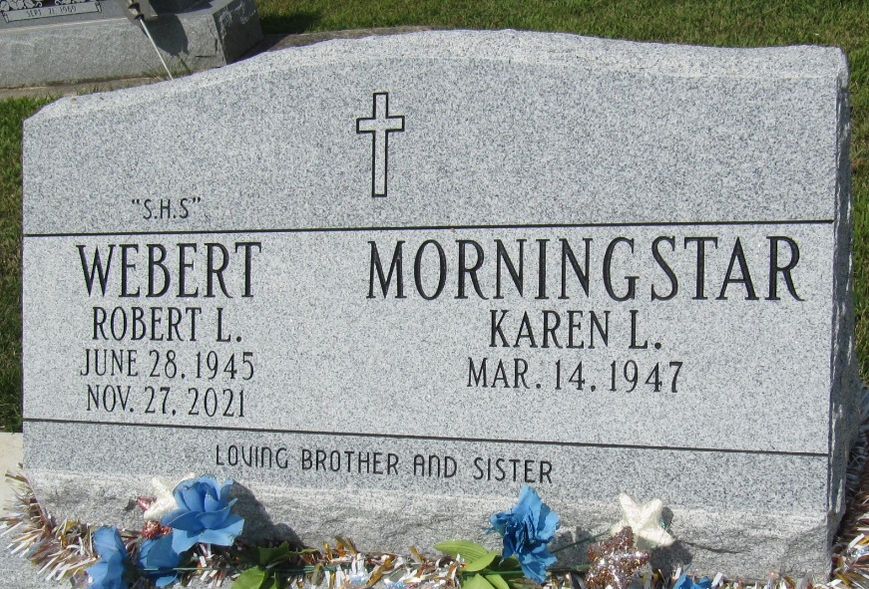
Photo by Deb Curry

Robert L. Webert, 76, of Decatur, Indiana passed away November 27, 2021 at Lutheran Hospital - Fort Wayne. He was born June 28, 1945, the son of the late Louis Webert and the late Helen (Gerke) Webert.
Bob was a veteran of the United States Air Force, serving during the Vietnam War. He was a former member of Holy Cross Lutheran Church in Ft. Wayne. Following his return to Decatur, he attended Zion Lutheran Church in Decatur.
He was employed with United Airlines as a ticket agent in Fort Wayne and Chicago, retiring in 2010.
Bob was very artistic. He received a Bachelor’s Degree in Fine Art from Indiana University. He loved his country and the United States Military. He was an avid reader and storyteller. His time in the military taught him the value of traveling, which he carried on upon his discharge and time with United.
Survivors include a son, Jonathan of Wolter San Francisco, California; sister, Karen L. Morningstar of Decatur, Indiana; four nieces, Angela Sonnenberg, Jennifer Morningstar, Jayla Buford, and Lindsey Slipher.
Private family services were held in following with Bob’s request.
Preferred memorials can be made to ACCF - Angel Fund - Diabetes, Hope Clinic in Decatur.

Zwick & Jahn Funeral Home, Adams County, Indiana
November 29, 2021

