Louis F. Webert
July 22, 1913 – November 25, 1986

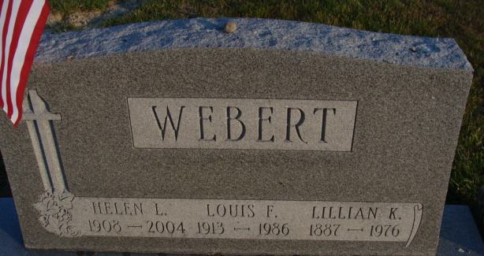
Photo by Deb Curry

Louis F Webert
in the Indiana, U.S., Death Certificates, 1899-2017
Name Louis F Webert
Gender Male
Race White
Marital Status Married
Age 73
Birth Date 22 Jul 1913
Birth Place Louisiana
Death Date 25 Nov 1986
Death Place Fort Wayne, Allen, Indiana, USA
Death Registration Date 1986
Father Louis G Webert
Mother Lillian K Johnson
Spouse Helen Gerke
Informant Helen Webert; wife; Decatur, Indiana
Burial December 1, 1986; Decatur Cemetery; Decatur, Indiana

