Mary G. Weber
May 22, 1920 – September 5, 2003

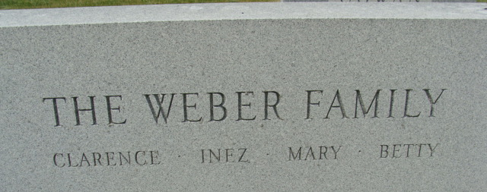
Photo by Alicia Kneuss

Mary G Weber
in the Indiana, U.S., Death Certificates, 1899-2017

Name Mary G Weber
Gender Female
Race White
Marital Status Never Married (Single)
Age 83
Birth Date 22 May 1920
Birth Place Adams County, Indiana
Death Date 5 Sep 2003
Death Place Decatur, Adams, Indiana, USA
Death Registration Date 2003
Father Clarence L Weber
Mother Inez Black
Informant Richard Linn; informant; Berne, Indiana
Burial September 8, 2003; Decatur Cemetery; Decatur, Indiana

