Johanna Wilhelmina (Marhenke)Weber
May 11, 1864 – February 20, 1914

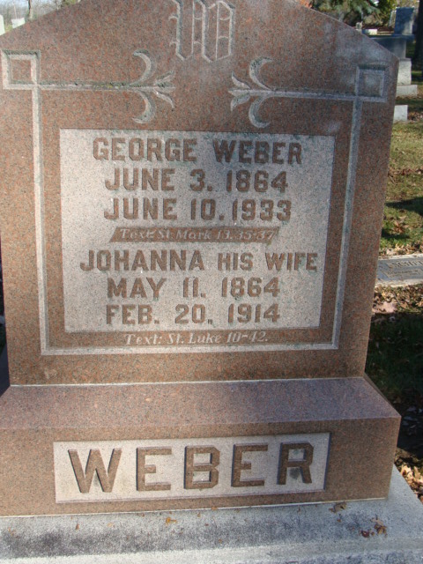
Photo by Alicia Kneuss

Hanah Wilhemina Weber
in the Indiana, U.S., Death Certificates, 1899-2017

Name Hanah Wilhemina Weber
[Hanah Wilhemina Marhenke]
Gender Female
Race White
Marital Status Married
Age 49
Birth Date 11 May 1864
Birth Place Indiana
Death Date 20 Feb 1914
Death Place Washington, Adams, Indiana, USA
Death Registration Date 1910-1919
Father Fredrich Marhenke
Mother Augusta Reilling
Spouse George Weber
Informant George Weber; Decatur, Indiana
Burial February 24, 1914; Decatur Cemetery

