Inez Ruth Ella (Black) Weber
June 24, 1899 – July 21, 1957

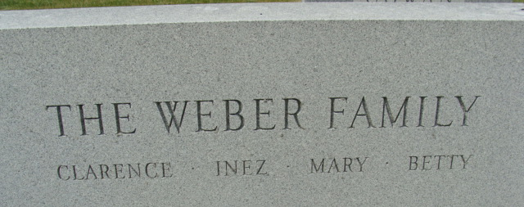
Photo by Alicia Kneuss

Inez Ruth Ella Weber
in the Indiana, U.S., Death Certificates, 1899-2017

Name Inez Ruth Ella Weber
[Inez Ruth Ella Black]
Gender Female
Race White
Marital Status Married
Age 57
Birth Date 24 Jun 1899
Birth Place Portland, Indiana
Death Date 21 Jul 1957
Death Place Fort Wayne, Allen, Indiana, USA
Death Registration Date 1957
Father Samuel E. Black
Mother Minnie G. Waltermeier
Informant Clarence L. Weber; husband; Decatur, Indiana
Burial July 24, 1957; Maplewood Cemetery; Decatur, Indiana

