Helena Bertha (Etzler)Weber
September 12, 1911 – October 23, 1976

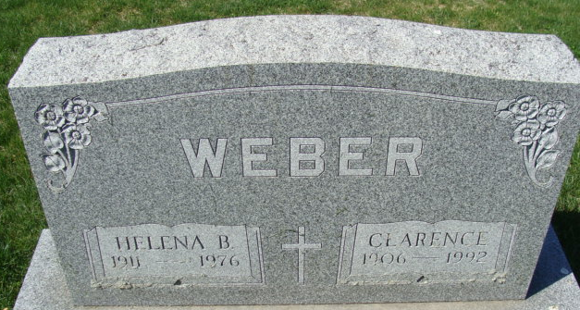
Photo by Alicia Kneuss

Helena Bertha Weber
in the Indiana, U.S., Death Certificates, 1899-2017

Name Helena Bertha Weber
[Helena Bertha Etzler]
Gender Female
Race White
Marital Status Married
Age 65
Birth Date 12 Sep 1911
Birth Place Ohio
Death Date 23 Oct 1976
Death Place Decatur, Adams, Indiana, USA
Death Registration Date 1976
Father Christian Etzler
Mother Justine Becker
Spouse Clarence Weber
Informant Clarence Weber; husband; Decatur, Indiana
Burial October 26, 1976; Decatur Cemetery; Decatur, Indiana

