George Heinrich Weber
June 3, 1864 – June 10, 1933

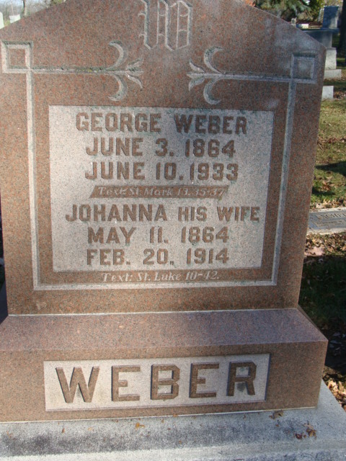
Photo by Alicia Kneuss

George Weber
in the Indiana, U.S., Death Certificates, 1899-2017

Name George Weber
Gender Male
Race White
Marital Status Widowed
Age 69
Birth Date 3 Jun 1864
Birth Place Root Twp
Death Date 10 Jun 1933
Death Place Washington, Adams, Indiana, USA
Death Registration Date 1933
Father Louise Weber
Mother Wilhelmina Aurenge
Spouse Hannah Marhenke
Informant Mr. Henry Fritcha; Decatur, Indiana
Burial June 12, 1933; Decatur Cemetery

