Clarence L. Weber
January 1, 1898 – January 11, 1963

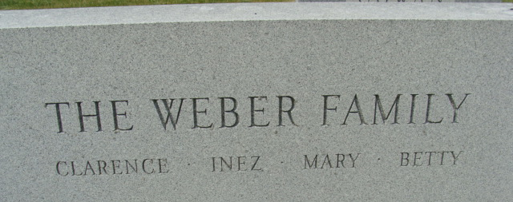
Photo by Alicia Kneuss

Indiana, U.S., Death Certificates, 1899-2017
Name Clarence L Weber
Gender Male
Race White
Marital Status Widowed
Military WW I
Age 65
Birth Date 1 Jan 1898
Birth Place Adams County, Indiana
Death Date 11 Jan 1963
Death Place Fort Wayne, Allen, Indiana, USA
Death Registration Date 1963
Father Louis Weber
Mother Mary Hale
Informant VA Hospital, Fort Wayne, IN
Burial 1-14-1963 Decatur Cemetery

