Clarence Weber
September 5, 1906 – March 11, 1992

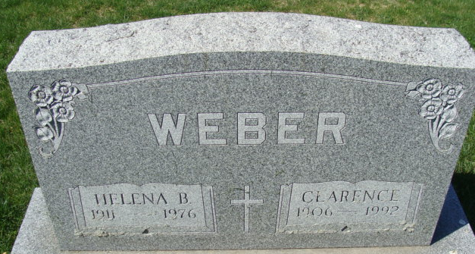
Photo by Alicia Kneuss

Clarence Weber, 95, of Decatur died yesterday in Swiss Village, Berne. He was a retired farmer and widower of Helena, who died in 1976.
Surviving are daughters, Ruth Mae Heffelmire of Tipton and Delores Rumple of Decatur; sons, Eugene F. of Decatur and Donald E. of Fremont; sisters, Wilma Busche of Fort Wayne, Martha Becker of Convoy, Ohio, and Mildred Bleeke and Helen Erxleben, both of Decatur; a brother, Robert of Decatur; 12 grandchildren; and five great-grandchildren.
Services are 11 a.m. tomorrow in Haggard & Armes Funeral Home, Decatur, where calling is 2 to 5 and 7 to 9 p.m. today. Burial will be in Decatur Cemetery.
Preferred memorials are gifts to Swiss Village or the Preble Volunteer Fire Department.

News-Sentinel, Allen County, Indiana
Thursday, March 12, 1992
**
Indiana, U.S., Death Certificates, 1899-2017

Name Clarence Weber
Gender Male; Race White
Marital Status Widowed
Age 85
Birth Date 5 Sep 1906
Birth Place Adams County, Indiana
Death Date 11 Mar 1992
Death Place Berne, Adams, Indiana, USA
Father William Weber
Mother Sophia Bieberich
Informant Delores Rumple; daughter; Decatur, Indiana
Burial March 13, 1992; Decatur Cemetery; Decatur, Indiana

