Betty J. Weber
September 8, 1926 – January 30, 1989

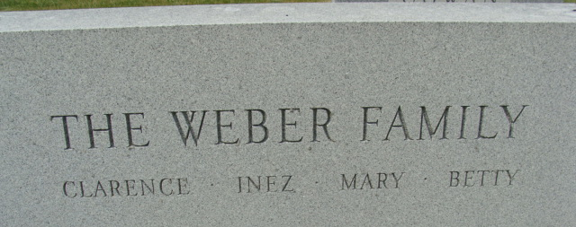
Photo by Alicia Kneuss

Betty J Weber
in the Indiana, U.S., Death Certificates, 1899-2017

Name Betty J Weber
Gender Female
Race White
Marital Status Never Married (Single)
Age 62
Birth Date 8 Sep 1926
Birth Place Decatur, Indiana
Death Date 30 Jan 1989
Death Place Decatur, Adams, Indiana, USA
Death Registration Date 1989
Father Clarence L Weber
Mother Inez Black
Informant Mary Weber; sister; Decatur, Indiana
Burial February 2, 1989; Decatur Cemetery; Decatur, Indiana

