Thomas Wildia Watts
March 31, 1855 – April 14, 1913

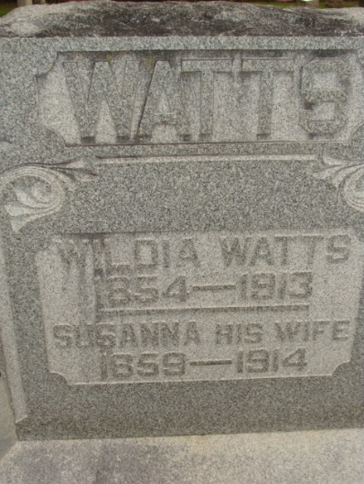
Photo by Alicia Kneuss

Thomas Wilda Watts
in the Indiana, U.S., Death Certificates, 1899-2017

Name Thomas Wilda Watts
Gender Male
Race White
Marital Status Married
Age 58
Birth Date 31 Mar 1855
Birth Place Mendon Ohio
Death Date 14 Apr 1913
Death Place Decatur, Adams, Indiana, USA
Death Registration Date 1913
Father Wesley Watts
Mother Anna Tates
Spouse Susanah
Informant Mrs. T. W. Watts; Decatur, Indiana
Burial April 17, 1913; Decatur Cemetery

