Susanna (Meihls) Watts
February 2, 1859 – June 13, 1914

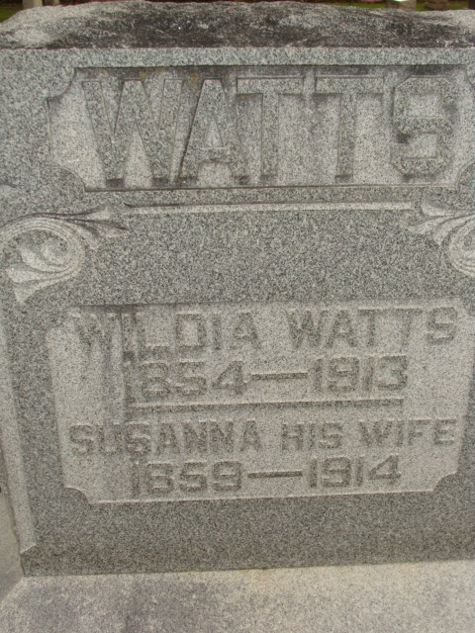
Photo by Alicia Kneuss

DIED LIST NIGHT
Mrs. T. W. Watts Passes Away At Daughter’s Horne at Grand Rapids, Mich. WAS ILL LONG
Survived Husband Little More Than A Year- Brought Here Monday

Surviving her husband, the late T. W. Watts, little more than a year Mrs. Susan Watts died last night, or early this morning at the home of her daughter, Myrtle, wife of Fred Bouse, at Grand Rapids, Michigan. Her husband died very suddenly April 13, 1913, of neuralgia of the heart and the wife never fully recovered from the shock. Added to this were complications of rheumatism and other ailments, which her reduced vitality was unable to withstand. For several weeks she had been very low and it was known that her recovery could not be made. Mrs. John Everett of this city visited a short time ago at her bedside, and she was very low at that time.
The body will be brought here for burial. The funeral party will arrive over the G. R. & I. at 2:11 o'clock Monday afternoon and the body will be taken at once to the Baptist Church where Mrs. Watts and her husband were both active members for so long.
The funeral services will be conducted from the church and interment will take place in the family lot in the Decatur Cemetery.
Of her immediate family, but the two daughters remain: Myrtle, wife of Fred Bouse of Grand Rapids, Mich., and Catherine, wife of William Walters of Newport News, Va.
Mrs. Watts' maiden name was Susan Miehls. Philip Miehls of this city is a brother. George Miehls of Monroeville and Mrs. Henry Ladig of Ft. Wayne are brother and sister.
The Watts family were residents of this city for many years. Since the death of Mr. Watts, Mrs. Watts has resided with her daughters. They were faithful members of the Baptist Church and most highly esteemed and well liked. Word of the death was received by telephone at twelve o'clock today by Cal Peterson, the funeral arrangements being given at that time.

Decatur Daily Democrat; Adams County, Indiana
Saturday, June 13, 1914
**
Susan Watts
in the Michigan, U.S., Death Records, 1867-1952
Name Susan Watts
[Susan Meihls]
Gender Female
Race White
Marital Status Widowed
Death Age 55
Birth Date 2 Feb 1859
Birth Place Ohio
Death Date 13 Jun 1914
Death Place Grand Rapids, Kent, Michigan, USA
Father George Meihls
Mother Unknown
Informant F. J. Bouse
Burial June 15, 1914; Decatur, Indiana

