Rosa Lee (Patrick) Watts
January 3, 1865 – December 19, 1943

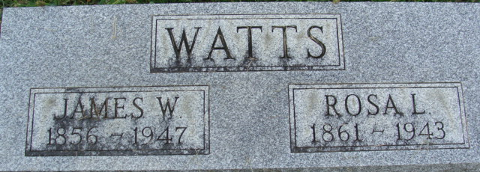
Photo by Alicia Kneuss

Mrs. Rosa Lee Watts, 78, wife of James Watts, died at 1:30 o'clock Sunday morning at the Adams County Memorial Hospital. She was born in Adams County on January 3, 1865, the daughter of John and Martha Eggy-Patrick, and was a lifelong resident of Adams County. She was married to James Watts, and they made their home at Monmouth.
Surviving besides the husband is a daughter, Mrs. Rhoda Hill of Decatur; one brother, Raymond Eggy of Florida; and two granddaughters. Two brothers preceded her in death.
Funeral services will be held at 3 o’clock on Wednesday afternoon al the Black Funeral Home, with Rev. F. H. Wilford officiating Burial will be in the Decatur Cemetery The body may be viewed at the funeral house after 7 o’clock this evening.

Decatur Daily Democrat, Adams County, Indiana
Monday, December 20, 1943

