James Wesley Watts
April 4, 1860 – November 27, 1947

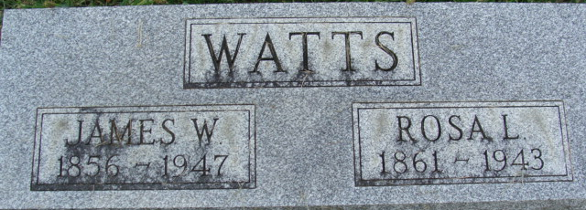
Photo by Alicia Kneuss

James Wesley Watts
in the Indiana, U.S., Death Certificates, 1899-2017
Name James Wesley Watts
Gender Male
Race White
Marital Status Widowed
Age 87
Birth Date 4 Apr 1860
Birth Place Spencerville Ohio
Death Date 27 Nov 1947
Death Place Decatur, Adams, Indiana, USA
Death Registration Date 1947
Father Wesley Watts
Mother Anna Gates
Spouse Caroline
Informant Mrs. Rhoda Hill; Decatur, Indiana
Burial November 29, 1947; Maplewood Cemetery; Decatur, Indiana

