Gordon A. Watts
March 14, 1933 – December 21, 2002

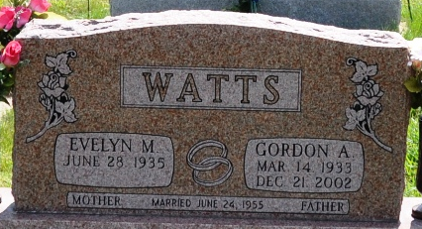
Photo by Barbara Baker Anderson

Indiana, U.S., Death Certificates, 1899-2017

Name Gordon A Watts
Gender Male
Race White
Marital Status Married
Age 69
Birth Date 14 Mar 1933
Birth Place Erie, Pennsylvania
Death Date 21 Dec 2002
Death Place Decatur, Adams, Indiana, USA
Death Registration Date 2002
Father unknown
Mother Gladys
Spouse Evelyn M Reed Watts, informant
Burial 12/23/2002 Decatur Cemetery
**
Gordon A Watts from tree Watts Family Tree
Birth 14 Mar 1933 Erie, Erie, Pennsylvania, USA
Residence Decatur, Adams, Indiana, USA
Death 21 Dec 2002 Decatur, Adams, Indiana, USA
Father Joseph Watts
Mother Gladys Cox (1912-1948)
Spouse Evelyn Reed (1935-2025)

