Evelyn M. (Reed) Watts
June 28, 1935 – July 29, 2025

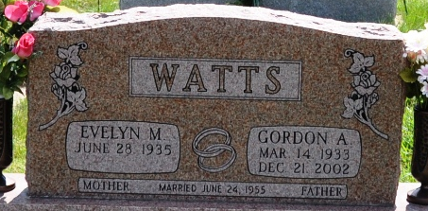
Photo by Deb Curry

Evelyn M. Watts, 90, of Decatur, passed away Tuesday morning, July 29, 2025, at Adams Woodcrest. She was born on June 28, 1935, in Ossian, IN, the daughter of James M. and Esther L. (Winters) Reed. On June 24, 1955, Evelyn married Gordon Watts, he preceded her in death on December 21, 2002.
She was a member of St. Mark’s Church, formerly a member of the Happy Homemakers and formerly a Girl Scout Leader for many years.
Evelyn helped to open the McDonald’s in Decatur and retired after 40 plus years of service.
She is survived by her son, Glenn A. (Susan) Watts of Decatur, IN; her daughters, Janis L. Watts of Trinity, FL, and Denise A. Shock of Decatur, IN; a brother, Gene M. (Deb) Reed of Monroeville, IN; a sister, Opal A. Frieburger of Ossian, IN; 5 grandchildren, Greg (Katie) Watts, Karen (Kyle) Milholland, Julie (Brad) Engle, Marissa (Trenton) Schinnerer, and McKinzie (Nick) Engle; 9 great grandchildren, Hallie & Conner Milholland, Brinley & Jackson Engle, Lincoln Watts, Braelynn, Brayden & Braylee Engle, and Rylee Schinnerer; lots of nieces, nephews, and friends.
Evelyn was preceded in death by her brother, Donald Reed; 3 sisters, Mary Silvers, Bonnie Hendericks and Carol Tustison.
A Funeral Service will be held at 11:00 a.m. on Friday, August 1, 2025, at Haggard-Hirschy & Zelt Funeral Home, with visitation 2 hours before the service from 9:00 – 11:00 a.m. Pastor David Reed will be officiating and burial will follow in Decatur Cemetery.
Memorials may be made to Heart-to-Heart Hospice or Adams County Cancer Coalition.

Haggard & Sefton Funeral Home, Adams County, Indiana
July 29, 2025

