Delmer C. Watson
September 7, 1926 – July 8, 2000

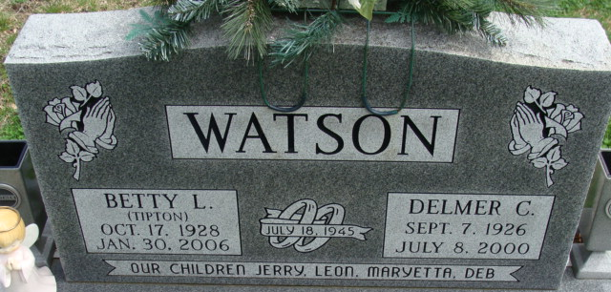
Photo by Alicia Kneuss

Delmer C. Watson
in the Indiana, U.S., Death Certificates, 1899-2017
Name Delmer C. Watson
Gender Male
Race White
Marital Status Married
Age 73
Birth Date 7 Sep 1926
Birth Place Estill County, Kentucky
Death Date 8 Jul 2000
Death Place Decatur, Adams, Indiana, USA
Death Registration Date 2000
Father Henry Watson
Mother Mary Lou Stewart
Spouse Betty L. Tipton
Informant Betty L. Watson; wife; Decatur, Indiana
Burial July 11, 2000; Decatur Cemetery; Decatur, Indiana

