Betty L. (Tipton) Watson
October 17, 1928 – January 30, 2006

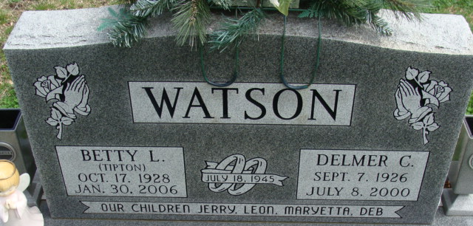
Photo by Alicia Kneuss

Betty L Watson
in the Indiana, U.S., Death Certificates, 1899-2017
Name Betty L Watson
[Betty L Tipton]
Gender Female
Race White
Marital Status Widowed
Age 77
Birth Date 17 Oct 1928
Birth Place Estill County, Kentucky
Death Date 30 Jan 2006
Death Place Decatur, Adams, Indiana, USA
Death Registration Date 2006
Father John Tipton
Mother Rosie
Informant Leon L. Watson; son; Decatur, Indiana
Burial February 3, 2006; Decatur Cemetery; Decatur, Indiana

