Russell L. Watkins
June 3, 1922 – June 11, 2010

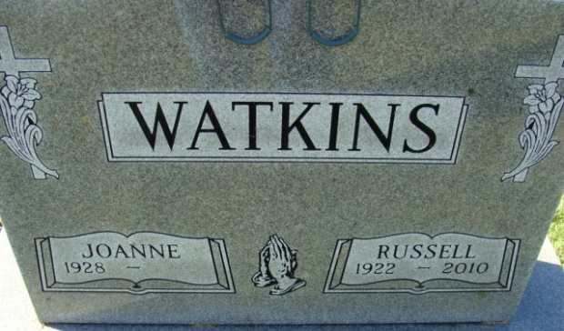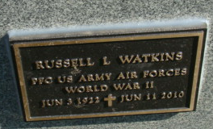
Photo by Alicia Kneuss

Russell L. Watkins, 88, of Decatur, IN died at 7:15 a.m. June 11, 2010 at Woodcrest Nursing Center. Russell was born on June 3, 1922 in Adams County, Indiana to the late William T. and Bessie (Durbin) Watkins. He married Jo Anne Boyce on July 26, 1947.
Russell was a member of the Pleasant Mills United Methodist Church and was a lifelong resident of Adams County. He worked on the assembly line for International Harvester for 35 years. He was a member of the American Legion Post #43, the U.A.W. and was on the Pleasant Mills Spartans High School Championship team in 1940. Russell served with the United States Army during World War II.
Survivors are his wife Jo Anne Watkins of Decatur, IN; a son Gary (Mary) Watkins; a daughter Kathy Petitt; a brother Marvin (Irene) Watkins all of Decatur, IN; grandchildren Wendy (John) Emerick, Nicole Watkins both of Decatur, IN and Amy (Terry) Bowling of St. Joe, IN; and three great grandchildren. Preceded in death are his parents and brother, Burvil Watkins.
Visitation will be 1-5 pm Sunday, June 13, 2010 at Haggard and Sefton Funeral Home. Funeral services will be at 10:00 am Monday, June 14, 2010 also at the funeral home. Rev. Steven Bard will be officiating. Burial will be in Decatur Cemetery with Military Graveside rites by the American Legion Post #43 Color Guard.
Memorials are to A.C.C.F. Angel Fund (Diabetes, Heart or Cancer) or Adams County Home Health.

Haggard & Sefton Funeral Home, Adams County, Indiana
June 12, 2010

