Marvin DeWayne Watkins
April 1, 1932 -

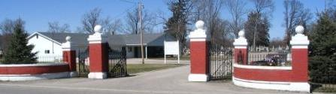
Photo by Barbara Baker Anderson

Marvin DeWayne Watkins
in the Indiana, U.S., Birth Certificates, 1907-1944
Name Marvin DeWayne Watkins
Gender Male
Birth Date 1 Apr 1932
Birth Place St Marys, Adams, Indiana, USA
Father Wm Watkins; age 37
Mother Bessie Durbin; age 33; 3rd child, all living
Certificate Number 13544
Roll number 40474_356546
Volume Range 26 - 30
**

IRENE SCHWARTZ, MARVIN WATKINS WED SATURDAY
Local Girl Is Bride In Pretty Ceremony in Pleasant Mills Church
Miss Irene May Schwartz, daughter of Mr. and Mrs. L. Reuben Schwartz, north of Berne, and Marvin Dewayne Watkins, son of Mr. and Mrs. William T. Watkins of rural route 6, Decatur, were united in marriage on Saturday evening at 6:30 o'clock at the Pleasant Mills Methodist Church. Vows in a double ring ceremony were exchanged before Rev. Harold T. Shady.

Adams County Historical Society, Adams County, Indiana
1933-1953 Scrapbook

