Lavon R. “Bonnie” (Strickler) Watkins
October 22, 1927 – February 5, 2019

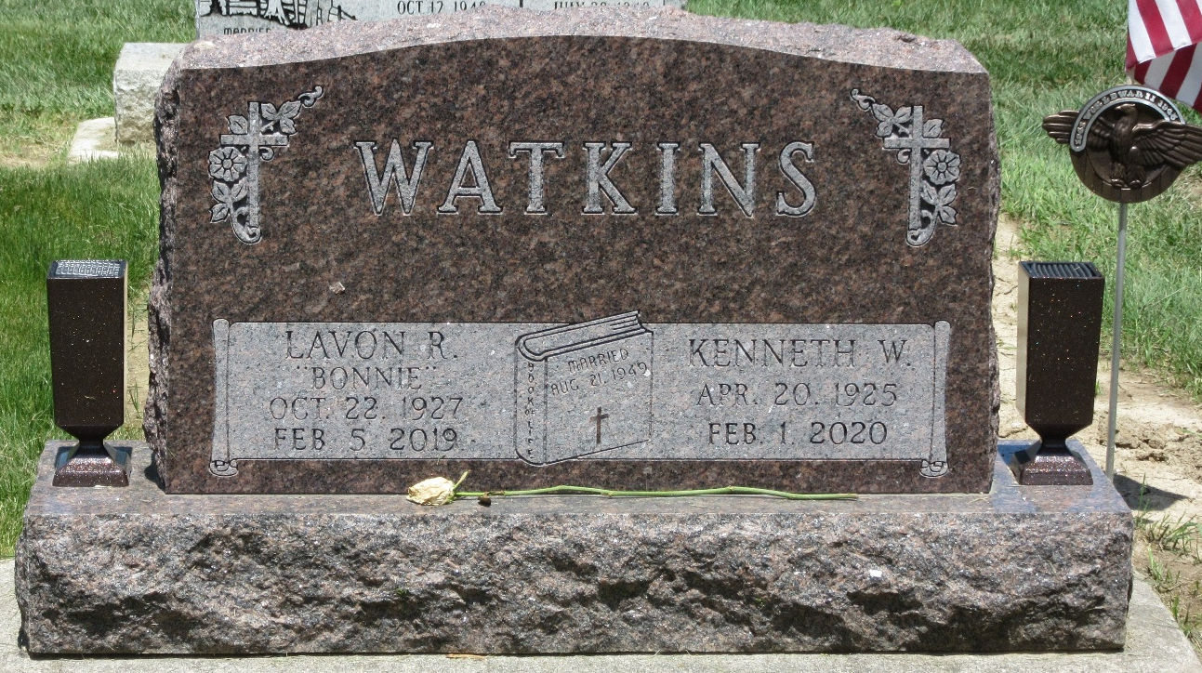
Photo by PLS

Lavon “Bonnie” Watkins, 91, of Decatur, Indiana passed away Tuesday evening, February 5, 2019 at Adams Woodcrest. She was born on October 22, 1927 in Decatur, Indiana, to the late C.W. Strickler and the late Mabel (Dunifon) Strickler. Bonnie was united in marriage to Kenneth Watkins on August 21, 1949 in Decatur, Indiana.
Bonnie was a lifetime faithful member of the Decatur Church of God were she was active in the church choir and directed the junior choir. She was also involved in the Woman of the Church of God, Junior Women in Decatur, and Research Club.
She was 1946 graduate of Decatur High School and attended Anderson College. She had also graduated from beauty college and had worked as a beautician. Later she worked as a teacher’s aide with North Adams Community Schools for twenty years.
Bonnie loved her family and adored her grandsons and great-grandson.
She is survived by her husband of 69 years, Kenneth Watkins of Decatur; two daughters, Angie (Jim) Foreman of Decatur and Robin (Phil Emenhiser) Woten of Decatur; brother, Larry (Coleen) Strickler of Payne, Ohio; four grandchildren, Nicholas Foreman, Arron (Kendall) Foreman, Nathaniel (Shay Moreman) Woten & Timothy Woten; and great-grandson, Simeon Foreman.
Bonnie was preceded in death by a grandson, Ryan Woten and a sister, Kathlene, in infancy.
A funeral service will be held at 11:00 a.m. Monday, February 11, 2019 at Decatur Church of God with Pastor Don Smith officiating. Burial will follow at Decatur Cemetery.
Family and friends will be received from 12 to 4 p.m. Sunday, February 10, 2019 at Zwick & Jahn Funeral Home in Decatur. Visitation also on Monday, February 11, 2019 from 8:30 to 9:30 a.m. at Adams Woodcrest Auditorium and from 10:00 to 11:00 a.m. prior to the service at Decatur Church of God.
Preferred memorials are to the Decatur Church of God Music Department.

Zwick & Jahn Funeral Home, Adams County, Indiana
February 6, 2019

