Kenneth W. Watkins
April 20, 1925 – February 1, 2020

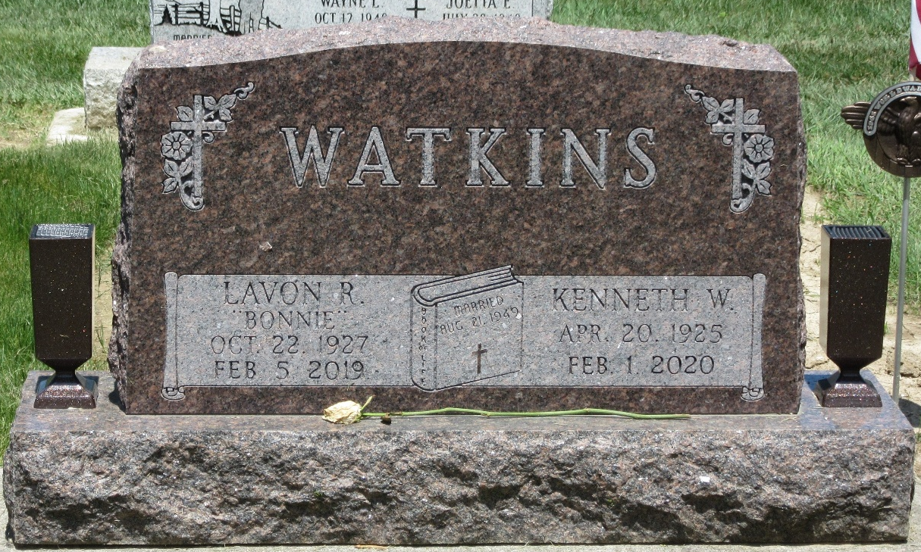
Photo by PLS

Ken W. Watkins, 94, of Decatur, Indiana, passed away on February 1, 2020 at Woodcrest Nursing Home, Decatur. He was born on April 20, 1925 in Anderson, Indiana, the son of the late Lynwood Watkins and the late Helen (Moyer) Watkins. Ken was united in marriage to Lavon “Bonnie” Strickler on August 21, 1949 in Decatur, Indiana; she preceded him in death on February 5, 2019.
Ken was a teacher for 11 years at Adams Central Community Schools and also taught at North Adams Community Schools. He managed Decatur Community Center and was an A.V. Supervisor at North Adams Community Schools.
Ken proudly served our country as a Major in the United States Army Air Corps during WWII and also served for many years in the Air Force Reserve following the war. Ken was a longtime active member of the Decatur Church of God. He was also former president of the Optimist Club of Decatur and member of Adams Post #43. Ken was known as an avid FOX News watcher.
Survivors include his 2 daughters; Angie (Jim) Foreman of Decatur, Robin (Phil Emenhiser) of Decatur; brother-in-law, Larry ( Sue) Strickler of Payne, OH; 4 Grandchildren, Nick (Jill Krick), Arron (Kendall) Foreman, Nathaniel (Shay Moorman), Tim (Tera Woolley) Woten and one great grandson, Simeon Foreman. He was preceded in death by a sister, Joan Plew; brother, Keith Watkins and also a Grandson, Ryan Woten.
Funeral services will be held at 11:00 a.m. Wednesday, February 5th at Decatur Church of God with Pastor Don Smith officiating. Interment will follow at Decatur Cemetery with military graveside honors by American Legion Post #43 Color Guard.
Friends will be received from 3:00 p.m. – 7:00 p.m. Tuesday at Zwick & Jahn Funeral Home, Decatur and 8:30 a.m. – 9:30 a.m. Wednesday at Woodcrest Chapel and one hour prior to services on Wednesday.
Preferred memorials to the Decatur Church of God Worship Arts.

Zwick & Jahn Funeral Home, Adams County, Indiana
February 2, 2020

