John Wilson Watkins
December 6, 1861 – October 11, 1938

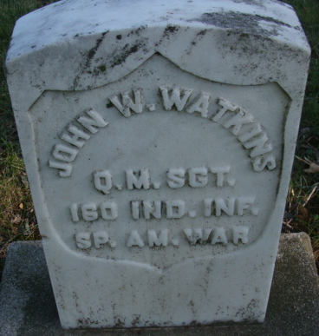
Photo by Alicia Kneuss

John W Watkins
in the Pennsylvania, U.S., Death Certificates, 1906-1972
Name John W Watkins
Race White
Gender Male
Death Age 76
Birth Date 6 Dec 1861
Birth Place Pleasant Mills, Ind
Death Date 11 Oct 1938
Death Place O'Hara, Allegheny, Pennsylvania, USA
Father Jesse T Watkins
Mother Mary Teepel
Spouse Clara Renark
Informant Veteran's Adm.; Pittsburgh, Pennsylvania
Burial or removal Decatur, Adams County, Indiana
Certificate Number 86965

**
John Wilson Watkins from tree Daniel Nestor family tree
Birth 6 Dec 1861 Pleasant Mills, Adams, Indiana, USA
Marriage 1884
Residence 1910 Adams, Indiana, USA
Death 11 Oct 1938 O'Hara Township, Allegheny, Pennsylvania, USA
Record information.
Father Jesse Thomas Watkins (1838-1907)
Mother Mary Teeple (1838-1914)
Spouse Clara E. Rurark (1861-1910)

