E. Joanne (Boyce) Watkins
May 27, 1928 – November 30, 2015

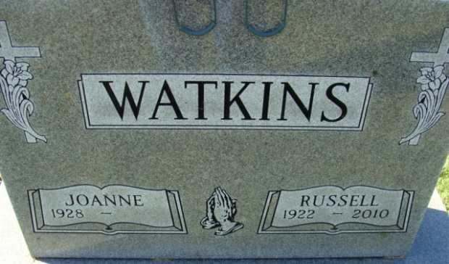
Photo by Alicia Kneuss

E. JoAnne Watkins, 87, of Decatur, passed away Monday, November 30, 2015 at Ossian Health Care. JoAnne was born on May 27, 1928 in Rockford, OH to the late Roland A. and Esther J. (Heil) Boyce. On July 26, 1947, she married Russell L. Watkins; he preceded her in death on June 11, 2010.
JoAnne was a member of Pleasant Mills UMC. She was a homemaker and also was an attendant for Speed Queen Laundry for 10 years.
She is survived by a son, Gary L. (Mary) Watkins; a daughter, Kathy A. Petitt both of Decatur; two brothers, John Boyce of Van Wert, OH and Tom Boyce of Rockford, OH; three grandchildren, Wendy (John) Emerick of Decatur, Amy (Terry) Bowling of St. Joe, IN and Nicole (Pat) Strack of Hoagland; five great grandchildren and 1 great-great grandson. She is preceded in death by two sisters-in-law, Judy and Grace Boyce and a brother-in-law, Burvil Watkins.
Funeral Service will be held on Friday, December 4, 2015 at 11:00 a.m. at Haggard-Sefton & Hirschy Funeral Home with calling 1 hour prior from 10:00-11:00 a.m. Rev. Stephen Bard will be officiating and burial will be in Decatur Cemetery.
Memorials are to Ossian Health Memory Care Unit and ACCF Angel Cancer Fund.

Haggard & Sefton Funeral Home, Adams County, Indiana
December 1, 2015

