Clara E. (Ruark) Watkins
1861 – November 12, 1910

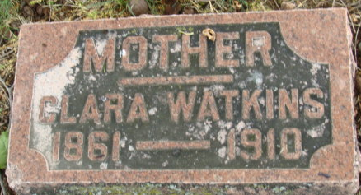
Photo by Alicia Kneuss

MRS. WATKINS DEAD
Well Known Woman of City Dies Suddenly Saturday Evening.
CEREBRAL APOPLEXY
She Had Been Ailing Several Months But Was Not Bedfast

Mrs. Clara Watkins, a well-known woman of this city, died suddenly Saturday evening at 6:13 o’clock, death being caused by cerebral apoplexy. Mrs. Watkins had been ailing for about two months from a nervous breakdown and suffered quite severely with pain in the head. She had not been bedfast, however, and only Friday had talked with friends on the street. Saturday afternoon she suffered an attack of cerebral apoplexy and her death was only a question of a few hours.
Mrs. Watkins was about forty-three years of age. She was born at Milton, Iowa, and was the daughter of James Rurark [sic -Ruark] of Indianapolis, who for several years has been one of the custodians of the state house.
Mrs. Watkins is survived by five children: Jesse of McKeesport, Pa.; John, Homer, Cecil and Mary, at home.
The funeral will be held tomorrow afternoon at 2 o’clock at the home on Second Street.

Decatur Daily Democrat; Adams County, Indiana
Monday, November 14, 1910

**
Indiana, U.S., WPA Death Index, 1882-1920
Name Clara Watkins
Date Nov 12, 1910
Location Decatur
Age 43 Yr
Gender Female
Race White
Source location City Health Office, Decatur
Source notes The source of this record is the book CH-12 on page 91 within the series produced by the Indiana Works Progress Administration.
**
Clara E. Rurark Ruark from tree Sahl-Watkins Family Tree
Birth Sep 1861 Milton, Van Buren, Iowa, USA
Marriage 30 Sep 1888 Howard, Indiana, USA
Residence 1910 Decatur, Adams, Indiana, USA
Death 12 Nov 1910 Decatur, Adams, Indiana, USA
Father James Franklin Ruark (1831-1862)
Mother Martha Elizabeth 'Mattie' Roberts (1835-1920)
Spouse John Wilson Watkins (1861-1938)

